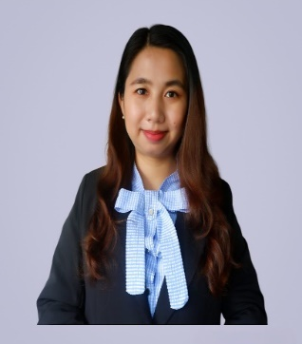

YOON YOON HTET
drafter engineer

Profile
Contact

iniInInfoInformation


Dependability and experience professional in Drafter Engineer(Steel Structure) bringing management eager to take on additional duty to accomplish deadlines. Passionate team member with a strong work ethic and complex problem-solving abilities. This profile will assist me in introducing users to my educational history,experience and development talents.

Ywar Ma Kyaung Lane(1), Kamaryut Tsp, Yangon
yoonhtet13@gmail.com
+959250253114 (WhatsApp)




Professional Experience
Personal information
Drafter Engineer May 2014 to Sep 2022
Leadcom (A Tech Manindra) Yangon, Myanmar

Project : Telecom Tower Strengthening and Retrofitting (Around 150sites)
Duties and Responsibilities,

- Involved in design, coordination and preparation of specification and plans and to liaise with Project Managers.
- Ensured progress schedule, quality standard is maintained, site inspection and technical issues are resolved on time.
- Made detail drawing of Tower strengthening steel member.
- Checked and prepared BOM for related projects and submitted to client.
- Prepared and checked shop drawing for fabrication at Workshop.
- Shop drawing preparation and well versed using with AutoCad.
- Collected data from Structural engineer and prepare analysis report to represent our client.
- In charged to draft all the standards specifications ensuring that customer approves it.

Project :Telecom Tower Constructions ( Around 300 sites)
Duties and Responsibilities,
- Prepared Detailed Design Drawing and managed site rectification.
- Made fabrication drawing of Rebar implementation for worker that is used for tower foundation construction.
- In charged to drafter and managed the drawing with specification and requirements that customer approved.
- Planned all the drawing requests to meet the submission dedline.
- Worked closely with the project team in coordination, organization and preparation of documentation and drawings.

M&E Maintenance Engineer Oct 2018 to August 2019
Myanmar Net Company Yangon, Myanmar

Duties and Responsibilities,

  - Coordinated with field operation and FTTH department
  - Coordinated with consultants and project management team about SBS project
  - Documents Controlling

DOB 13.2.1991
Passport No MF378685
Nationality Myanmar
Marital Status Single
Availability Immediately
Expected salary 2500SGD (Nego:)

Professional Skills
- Able to work under pressure
- Good at time management
- Interpersonal skill
- Leadership skill
- Team player
- Fast learner
- Detail oriented
- Hardworking
- Creativity

3
- Bachelor Of Civil Engineering
(2007-2012) Taunggyi Technological University, (Myanmar)
Cumulative GPA 4.49 out of 5

Professional Experience

Academic background
Professional Experience

Academic background d
Academic background
Drafter May 2013 to April 2014
K&K Drawing and Construction Yangon,Myanmar
Duties and Responsibilities,

- Drafted preliminary Steel Structure Building for CDC approval.
- Planed, execute and finilaze projects base on the structural engineer remarks and submitted to CDC to get build permit .
- Coordinated the efforts of team members, house owner and third-party.
- Revised drawings and layout to accommodate changes and enhancements.

Other Certificate

Draft Experience

- AutoCad Intermediate Course (KTC Training Center)
- Architecture and Interior Technical Drawing Workshop (NeoCreative Design Service)
- SQS Trainging Center _Revit Architectural Course (50hrs)
- QS Steel intermediate and advanced Course (DYYH Engineering Training Center)
- QS RC (Unique Home MM co.,Ltd)
- BIM Modelling (BIM) is under training.

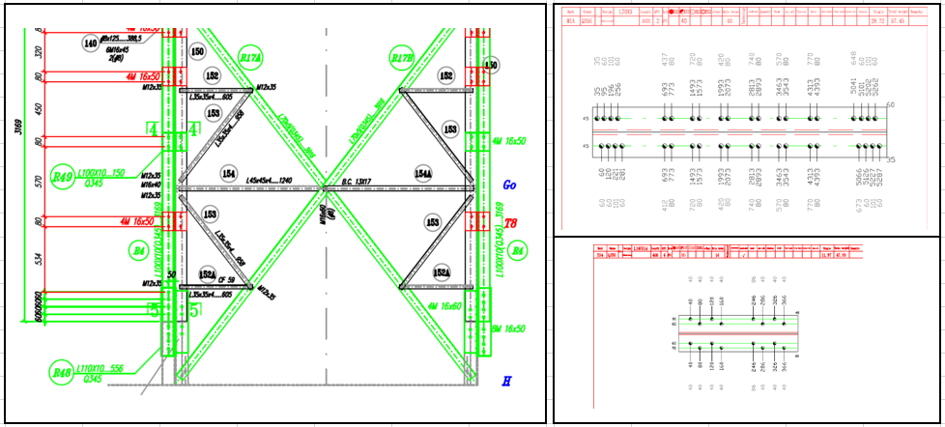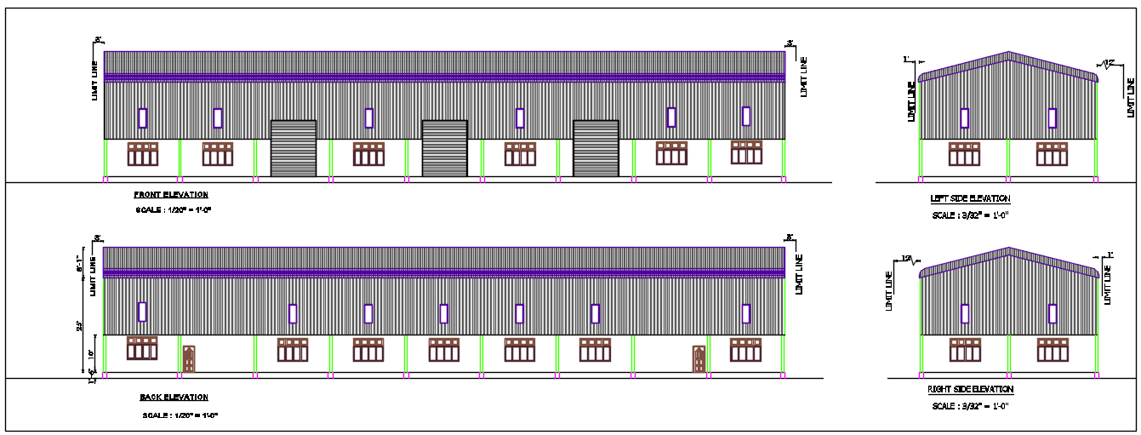

Summary

Looking for a challenging role in a reputed company to utilize about 8years engineering skills that can contribute to the company’s growth as well as enhance my knowledge by exploring new things.
I hereby declare that all above information is true and correct one.

With Best Regards,
Ms.Yoon Yoon Htet
+959250253114(Whatsapp)
Yoonhtet13@gmail.com

Language
- English (Intermediate)
- Mandrain (Basic)
- Burmese (Native)

